Analysis of MSE and PSNR

## Samriddhi Varshney

230123057

### Objective

To compute the following image quality metrics for the compressed images:

* Mean Squared Error (MSE),
* Peak Signal-to-Noise Ratio (PSNR)

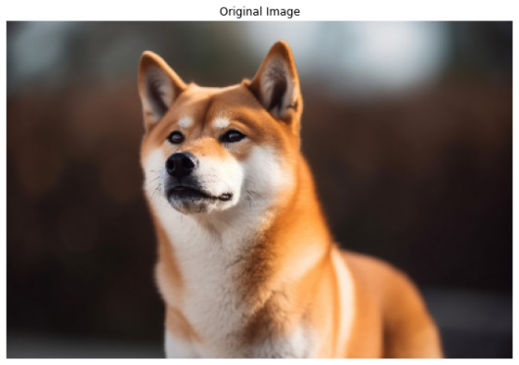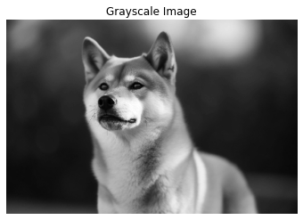

Figure 1: Left: Original image Right: Grayscale image.

### MSE and PSNR Formulas

**Mean Squared Error (MSE)**

Mean Squared Error (MSE) is used to measure the average squared difference between the original and reconstructed values. The formula for MSE is:

where: - Aij is the original value at position (i, j), - ˆAij is the reconstructed value at position (i, j), - m and n are the dimensions of the matrix.

**Peak Signal-to-Noise Ratio (PSNR)**

Peak signal-to-noise ratio (PSNR) is the ratio between the maximum possible power of an image and the power of corrupting noise that affects the quality of its representation. It is calculated using the following formula:

where: - MAX is the largest possible pixel value), - MSE is the Mean Squared Error.

### Plot Analysis

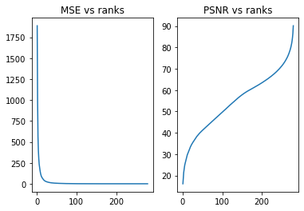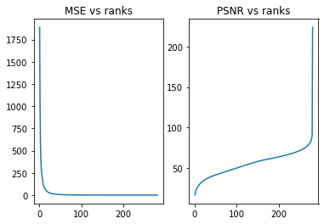

Figure 2: Plots of MSE vs ranks and PSNR vs ranks a) for AAT, b) for ATA

**Interpretation**

After a certain value of r, the MSE value becomes stagnant implying that a lot of data can be discarded and hence a lot of space can be saved without compromising the quality of the image too much. The PSNR rises rapidly at first, meaning that adding the initial singular values contributes significantly to improving the quality. Like MSE, the PSNR also shows a point where the rate of increase slows down, meaning the further information added can be ignored without affecting the quality.

MSE values for both cases are the same but there is a difference in PSNR for both SVDs.

### Conclusion

The analysis of the graphs reveals that both MSE and PSNR are dependent on rank. While lower ranks result in poorer approximations, as shown by higher MSE and lower PSNR, increasing the rank improves the quality. After a certain point, further increases in rank provide negligible results, giving us a rank to make a trade-off between the quality and size of the image.